Schedule a Meeting in Teams
There are several ways to schedule a meeting in Teams:
1. Select Schedule a meeting in a chat (below the box where you type a new message) to book a meeting with the people in the chat.
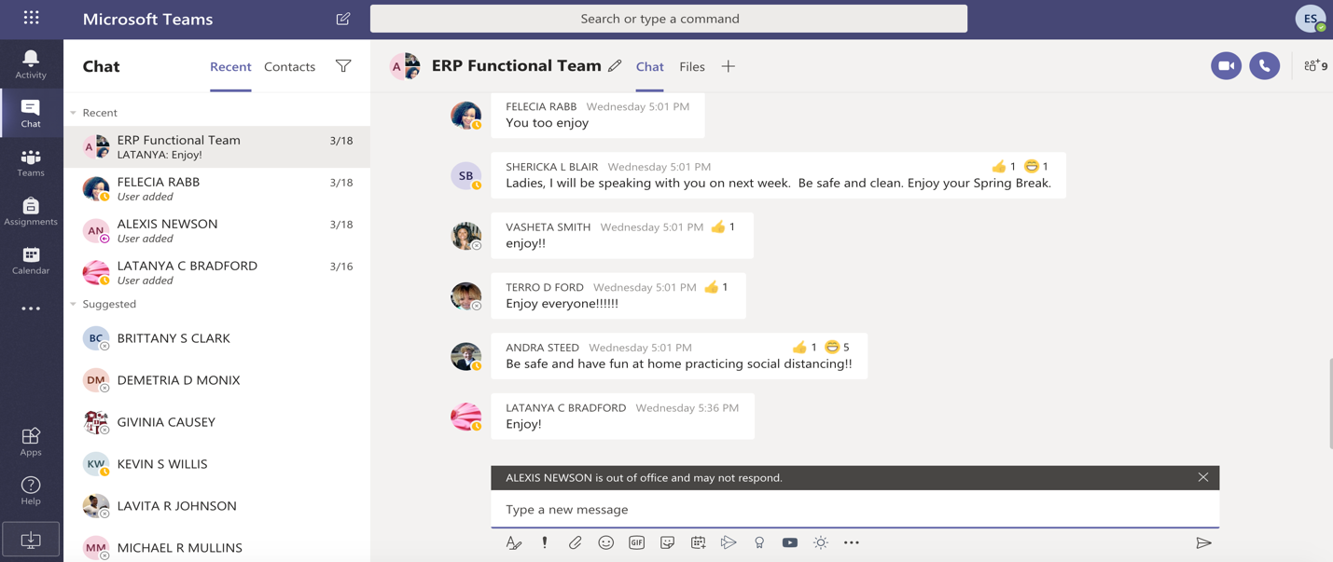

OR
1. Go to Calendar on the left side of the app and select New meeting in the top right corner. (If it does not appear, click on the ellipses show all options.)
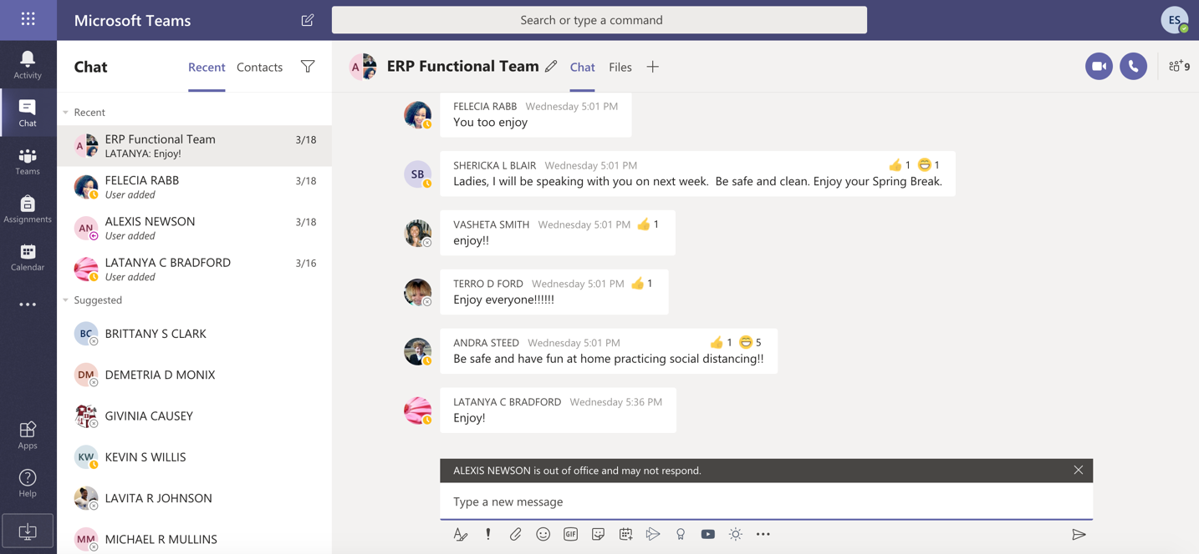

2. A scheduling form will open.
The scheduling form is where you'll give your meeting a title, invite people, and add meeting details.
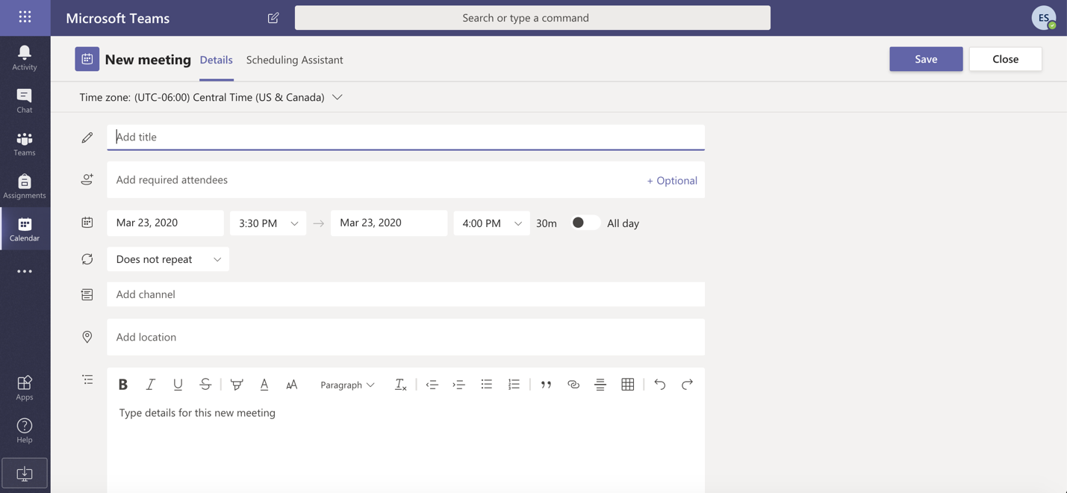
Use the Scheduling Assistant to see everyone’s schedule in a calendar view and find a time that works for everyone.
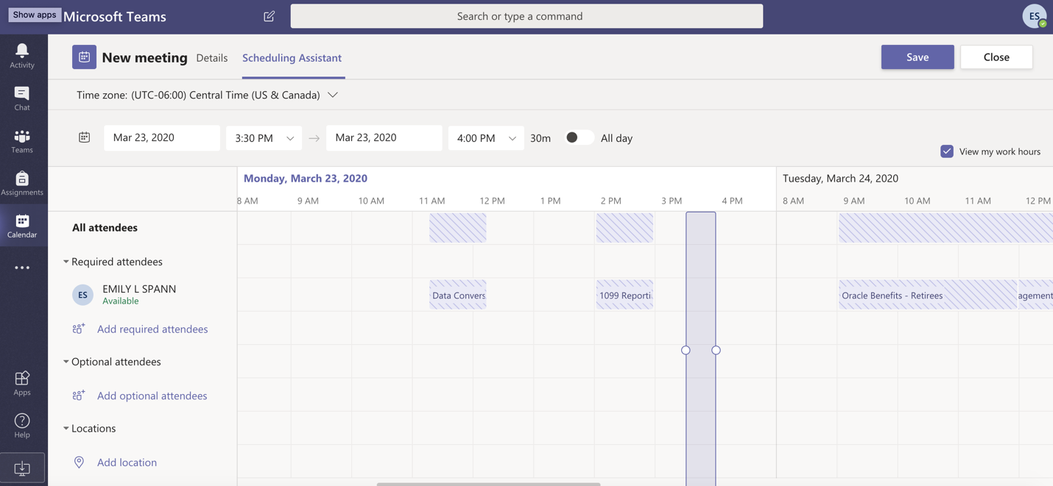
3. Once you're done filling out the details, select Save. This will send an invite to everyone's Outlook inbox.

